Nama : Muhammad Ilham Syaifullah

1. File Kotlin benih

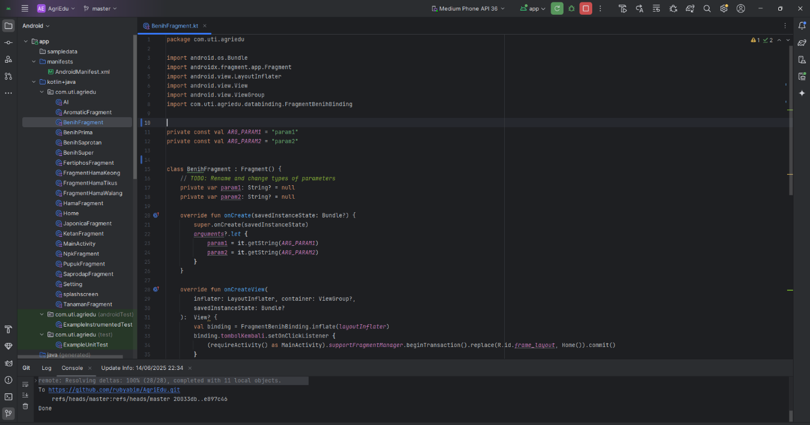

1. File Kotlin Benih Prima

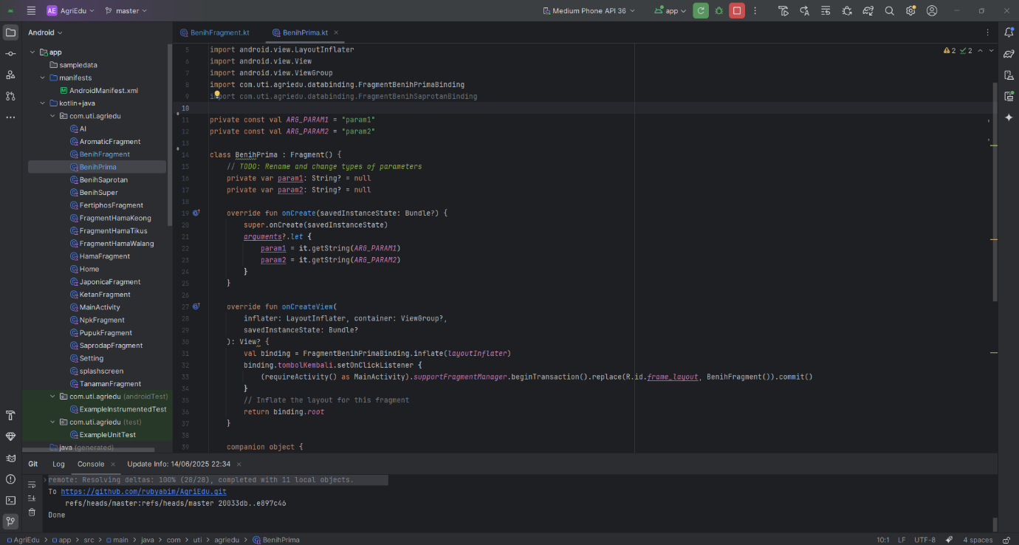

1. File Kotlin Benih Saprotan

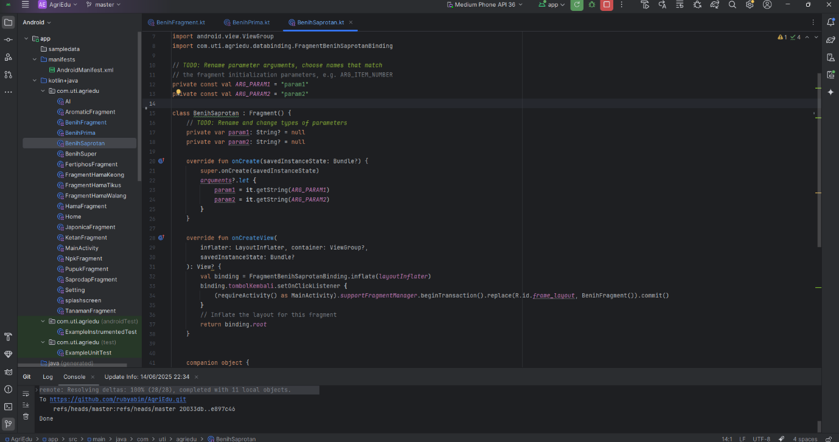

1. File Kotlin Benih Super

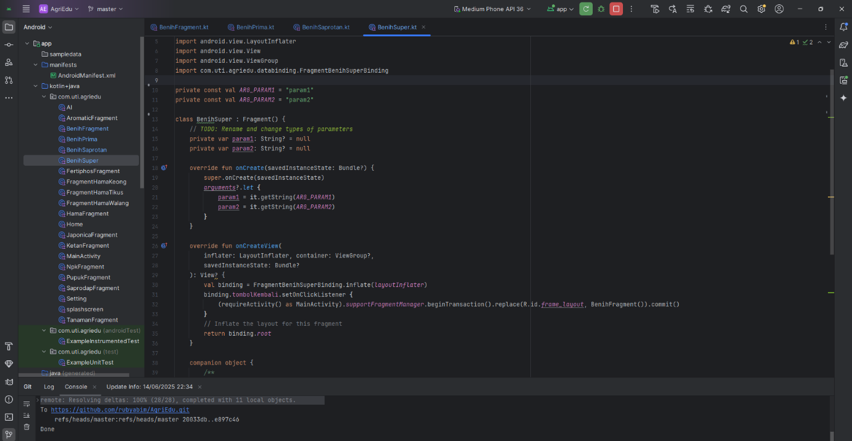

1. File Kotlin Hama Keong

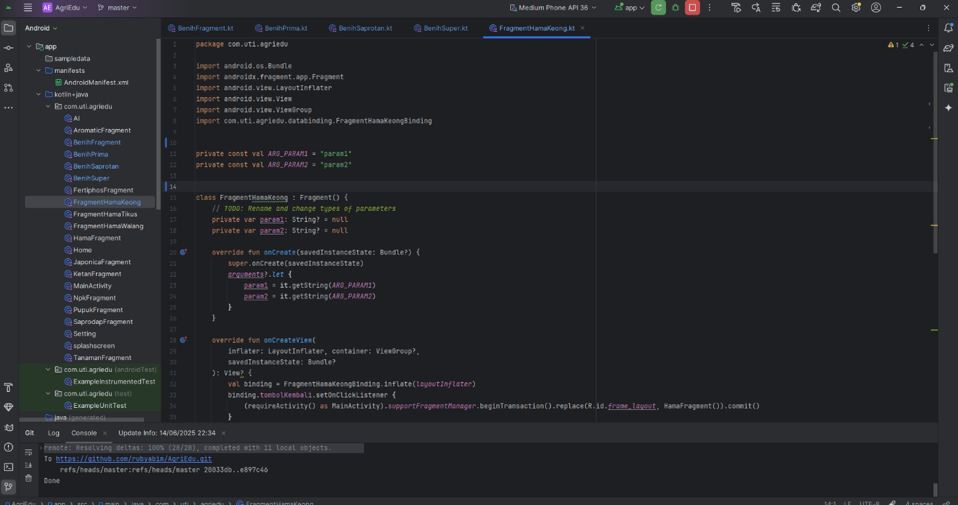

1. File Kotlin Hama Tikus

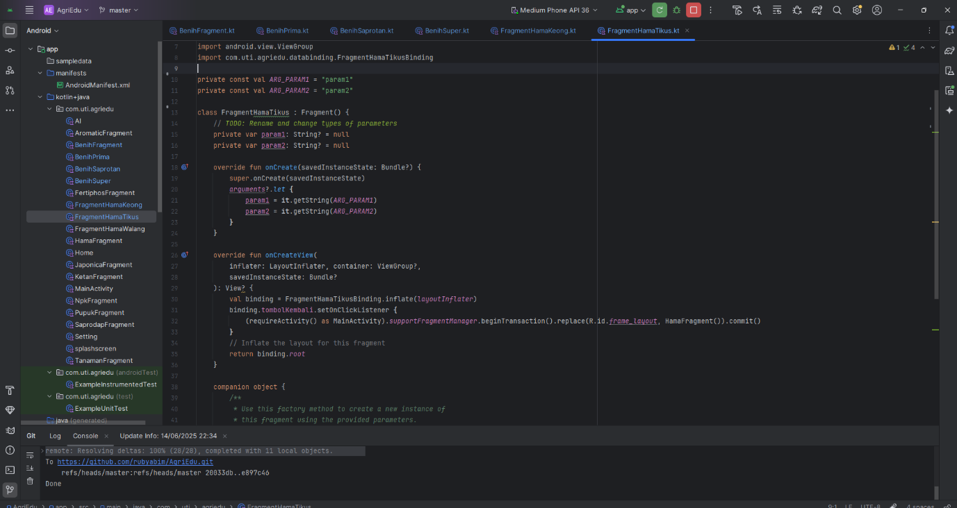

1. File Kotlin Hama Walang

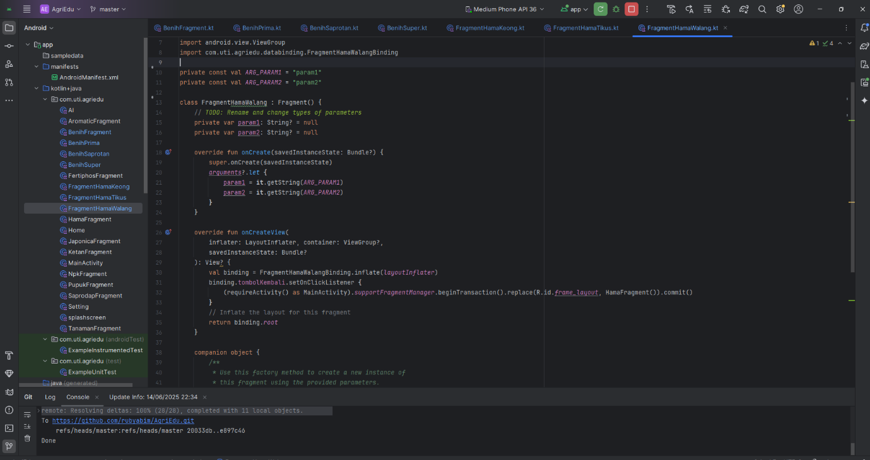

1. File Kotlin Hama

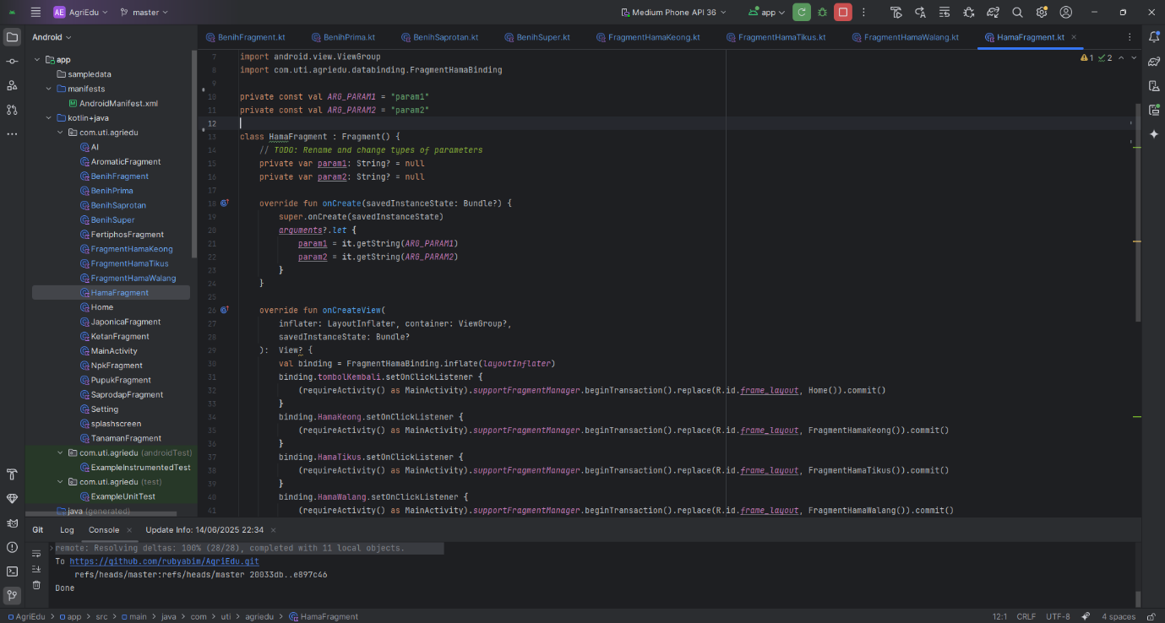

1. File xml Benih

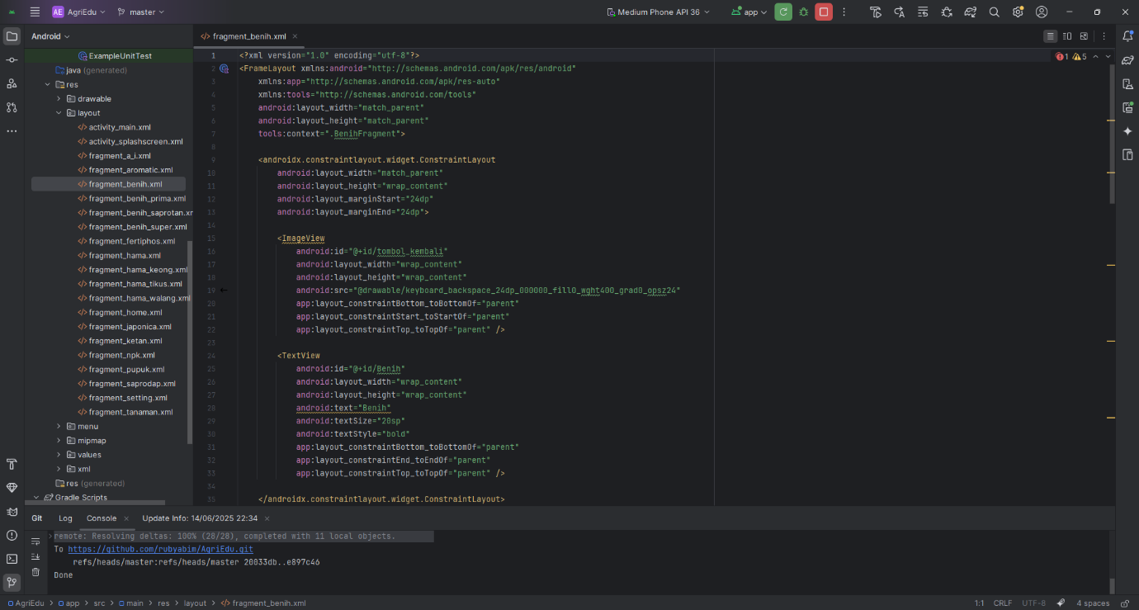

1. File xml Benih Prima(detail)

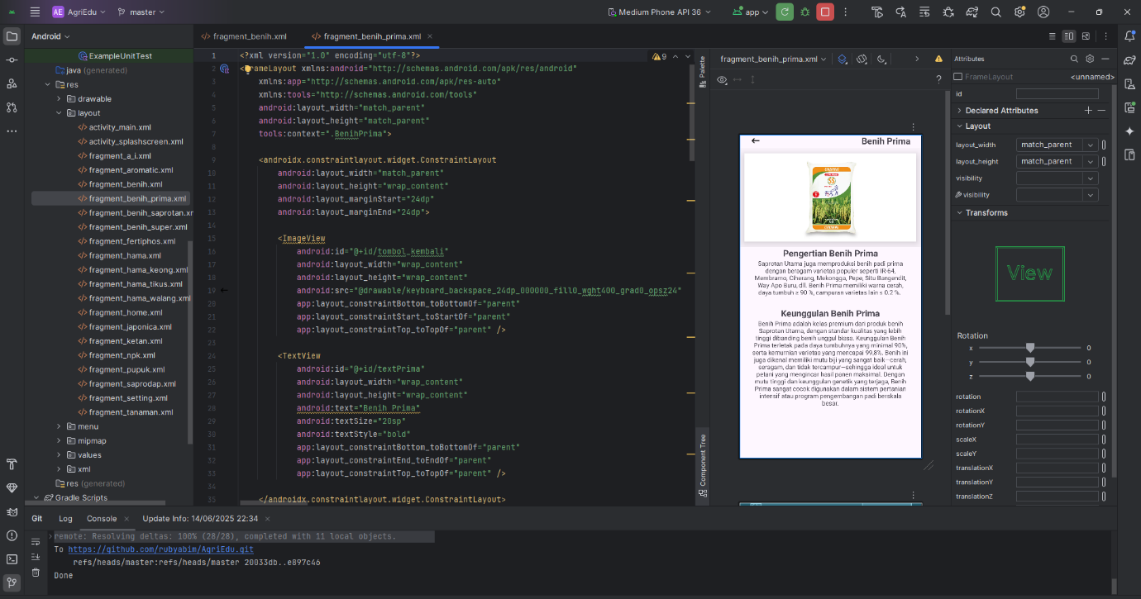

1. File xml Benih Saprotan(detail)

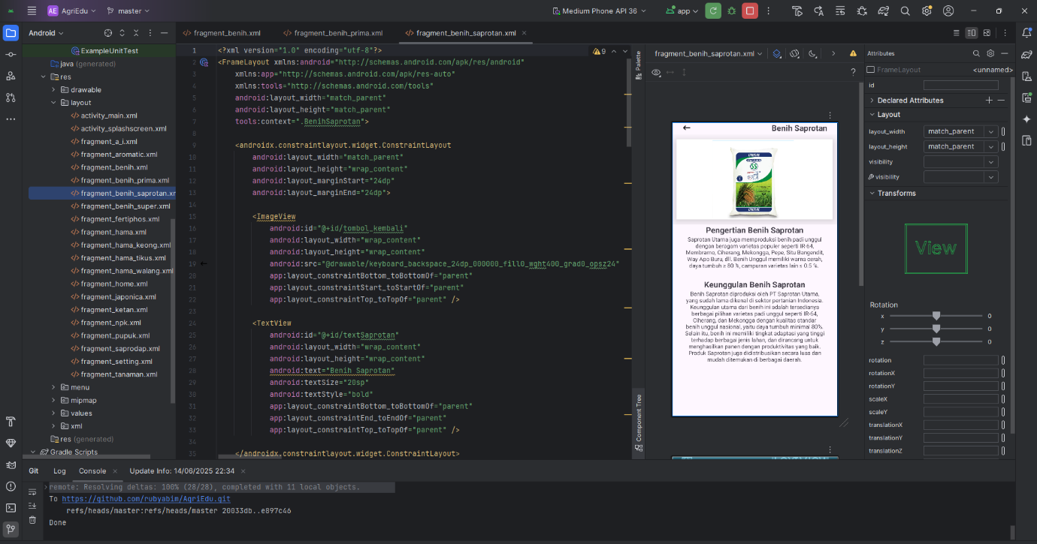

1. File xml Benih Super (detail)

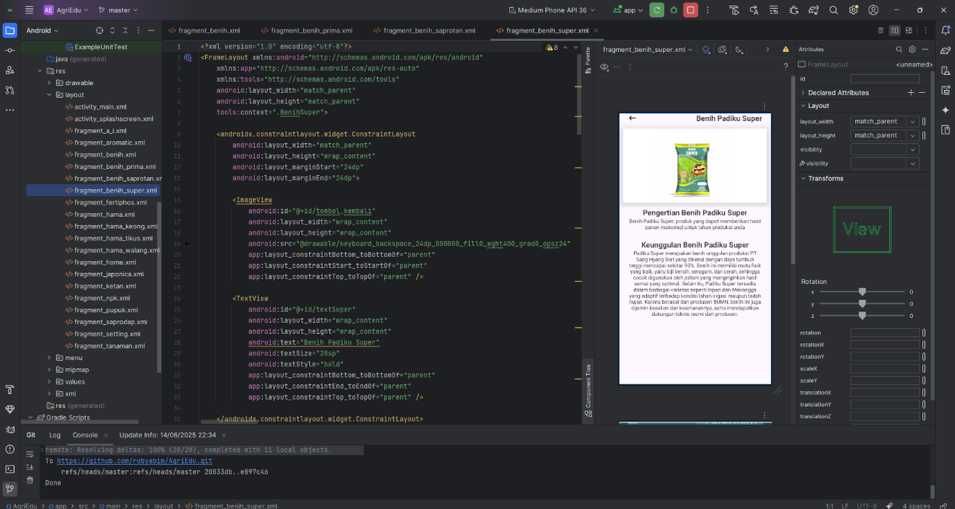

1. File xml Hama

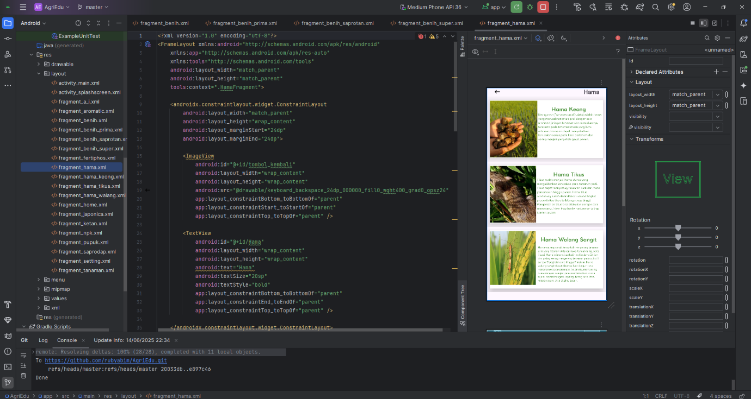

1. File xml Hama Keong(detail)

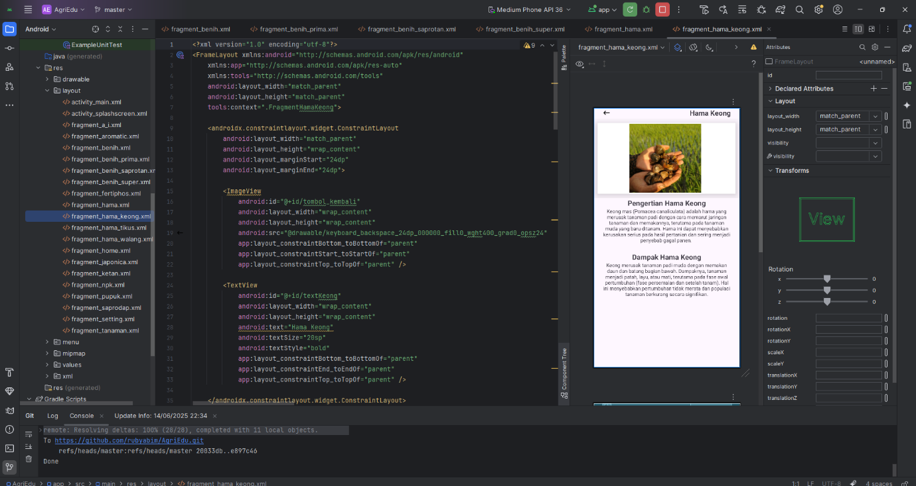

1. File xml Hama Tikus (detail)

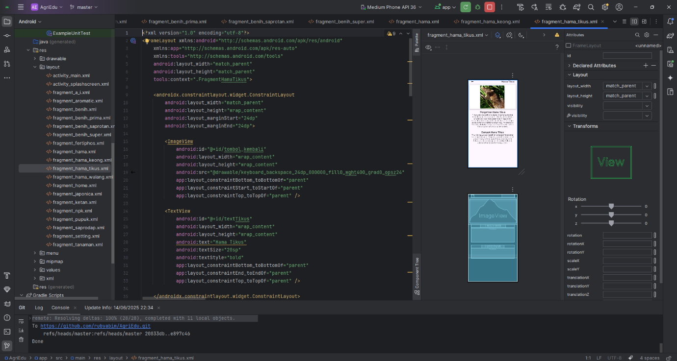

1. File xml Hama Walang

